Issue 1: Graph looks too weird and complicated.
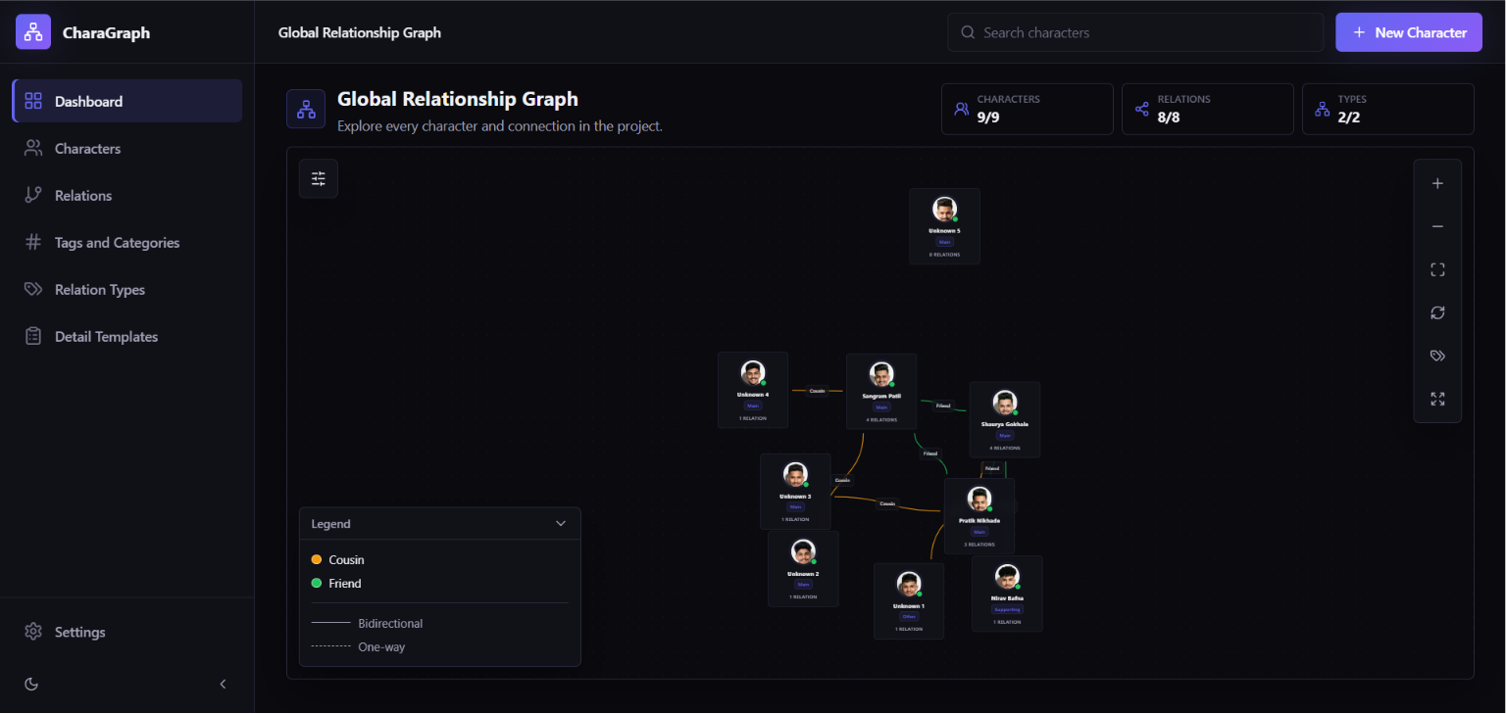
For a few characters, the graph looks good but when the characters are increased, we get this mess. The connections cards are getting overlapped by other cards, the default view is for showing all the cards at once so initial view is too small for multiple characters. This is the view where I adjusted everything manually:
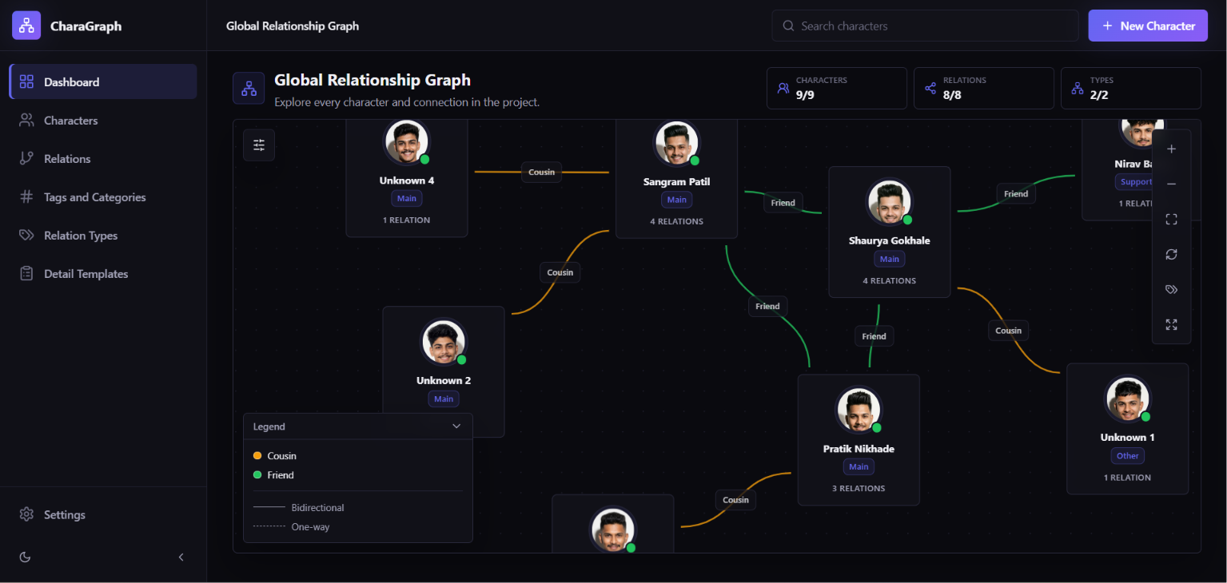
We are not trying to fit everything in the initial default view. All the connections are optimized to be non-overlapping; no card is overlapping any other card or connection.
I think the issue will also occur in the individual character relation graph in their profiles too.
Location: Dashboard page – global character relationship graph
Issue 2: Problem with relations
I have set 3 subtypes in the friend relation:
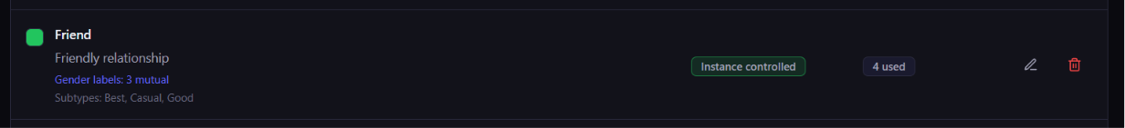
First issue here is when I go to a character and try to add a relation, the dropdown to select a relation is stuck (no options visible) I only can select the default first relation, same for the status dropdown. Also I don’t see an option to select a subtype although I am not sure if we see it only when we select a relation which has any subtypes:
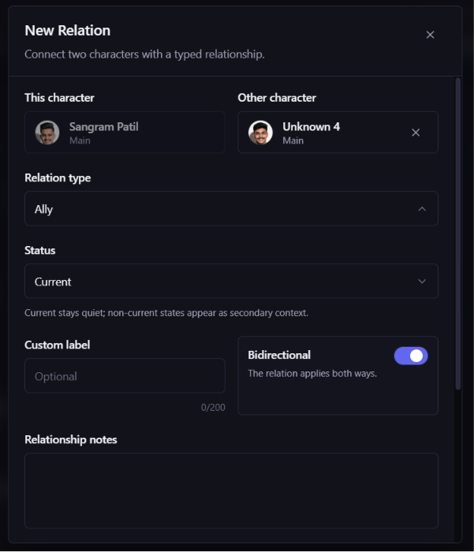
Location: Character relation add/edit (both character profile and separate page)
Issue 3: Similar dropdown issue in Relation Types add/edit relation and other issues there
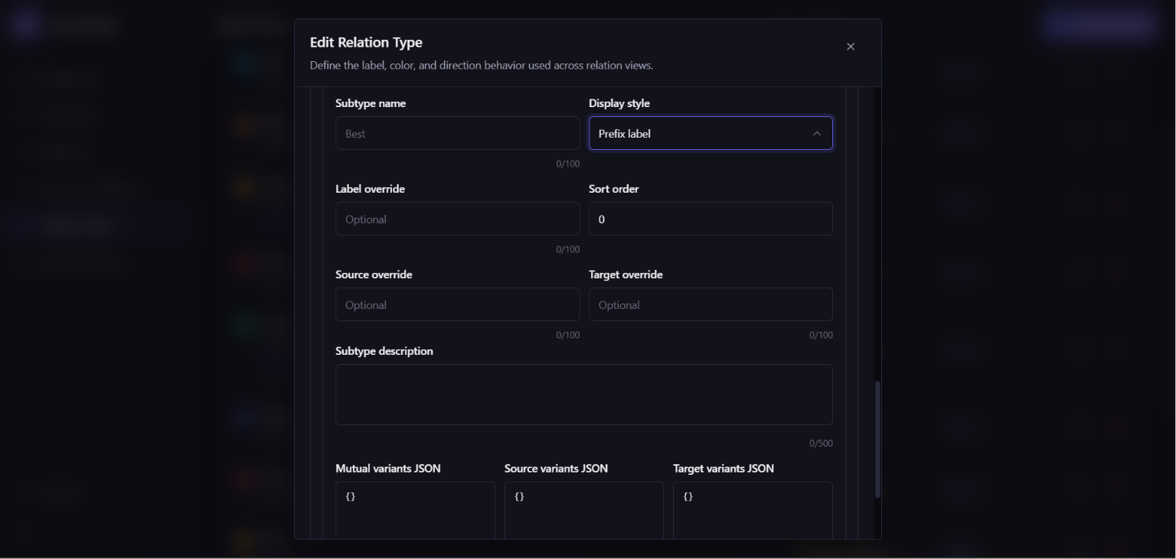
Here also the Display style dropdown has no visible options. Also, it would be better if we add some I button or tip to tell what Mutual variants JSON, Source variants JSON and Target variants JSON are.
Location: Relation Types Page
Also one more issue, the DB initialization is I think now not required, we can keep the DB empty. Just if the file is not present we can create it. This way we will get a fresh unused app. Because this is affecting things, for e.g. I had deleted multiple relations and now as I started the app today they are back, same happened for status, gender and role etc.

